Encrypted Chat Application - Internship Report Muhammad Hamza Siddique Shaker Syntecxhub 1 Month Encrypted Chat Application (Python)
Encrypted Chat Application - Internship Report
Intern Name: Muhammad Hamza Siddique Shaker
Organization : Syntecxhub
Internship Duration: 1 Month
Project Title: Encrypted Chat Application (Python)

Introduction
This internship report documents the development of a professional, secure, multi-client chat application using Python. The project demonstrates practical skills in encryption, socket programming, threading for concurrency, and message management. This experience highlights understanding of client-server architecture, cybersecurity principles, and professional project documentation standards.

Table of Contents
- Project Objective
- Technologies Used
- Folder Structure
- Step-by-Step Implementation
  - 4.1 Python Installation
  - 4.2 Server Execution
  - 4.3 Client 1 Execution
  - 4.4 Client 2 Execution
  - 4.5 Encryption Demonstration
- Features
- How It Works
- Learning Outcomes
- Conclusion

1. Project Objective
The objective of this project is to create a secure chat application where multiple clients can exchange messages encrypted with AES, ensuring confidentiality and integrity. This project allows hands-on experience in Python programming, networking, concurrency, and encryption.

2. Technologies Used
Technology | Purpose
Python 3.14 | Core programming language
PyCryptodome | AES Encryption for secure messaging
TCP Socket Programming | Network communication
Threading | Concurrent handling of multiple clients
Base64 | Encoding messages for safe transmission
Windows CMD | Execution and testing environment
Table style: Header row with navy background and white bold text; alternating row colors in light blue and light gray for clarity and professional design.

3. Folder Structure
D:_chat
├── server.py
├── client.py
├── crypto_utils.py
├── requirements.txt
├── chat.log
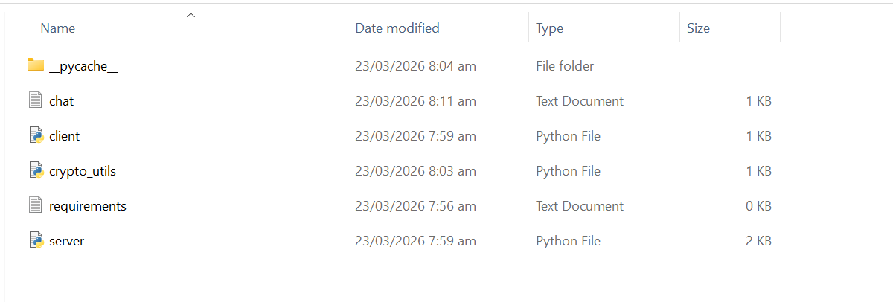

4. Step-by-Step Implementation

4.1 Python Installation
- Installed Python 3.14 on Windows.
- Verified installation using python --version.
- 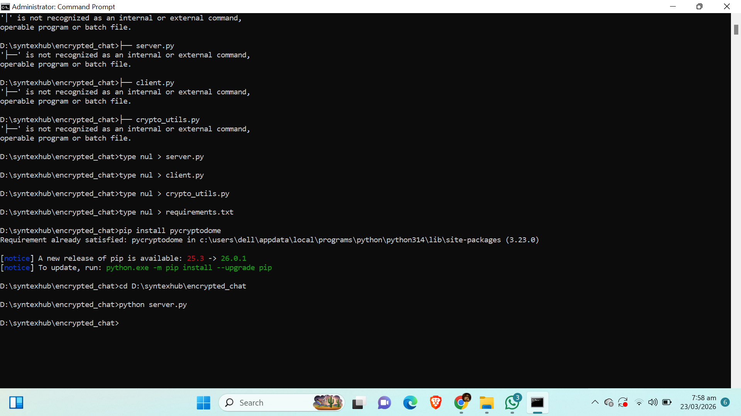

4.2 Server Execution
- Execute server.py.
- Server listens at 127.0.0.1:12345.
- Supports multiple clients concurrently.
- 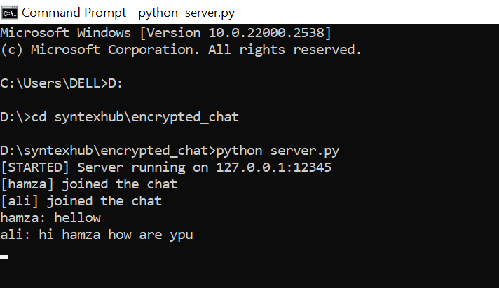

4.3 Client 1 Execution
- Run client.py.
- Enter username (e.g., Hamza).
- Client connects to server and waits for others.
- 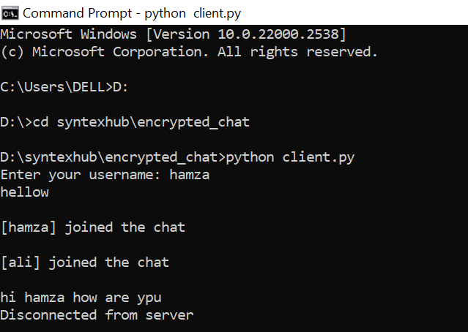

4.4 Client 2 Execution
- Run second client.py instance.
- Enter username (e.g., Ali).
- Messages can now be exchanged securely.
- 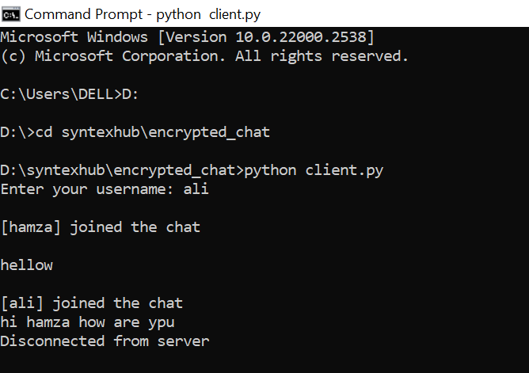

4.5 Encryption Demonstration
- Messages are encrypted using AES in CBC mode.
- Random IV ensures security.
- Server decrypts and broadcasts messages.
- 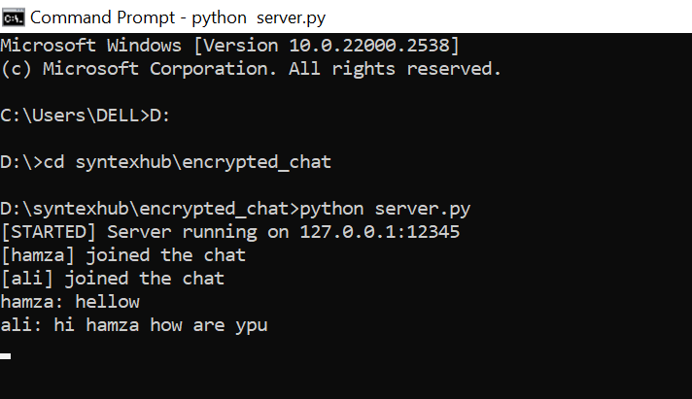

5. Features
- Multi-client chat system
- AES encrypted messaging
- Username-based identification
- Join/leave notifications
- Message logging (chat.log)
- TCP socket-based communication

6. How It Works
- Server continuously listens for incoming client connections.
- Clients connect and provide their username.
- Messages are encrypted at client-side and sent to the server.
- Server decrypts, logs, and broadcasts messages.
- Clients decrypt received messages for display.

7. Learning Outcomes
- Client-server architecture implementation.
- AES encryption for secure communication.
- Multi-client handling with threads.
- TCP socket programming skills.
- Logging and message history management.

8. Conclusion
This project demonstrates secure communication in a chat system using AES encryption. It highlights Python programming skills, networking concepts, concurrency, and cybersecurity practices. The experience provides practical knowledge applicable in professional internship scenarios.

Appendices
- Screenshots of installation, server and client executions, and encryption demonstration.
- Folder structure image.

End of Report

